ContactManagement_Verify Contact notes _Instance44_12-Jul-2018_06-27-05_AM_SingleSignOn.png

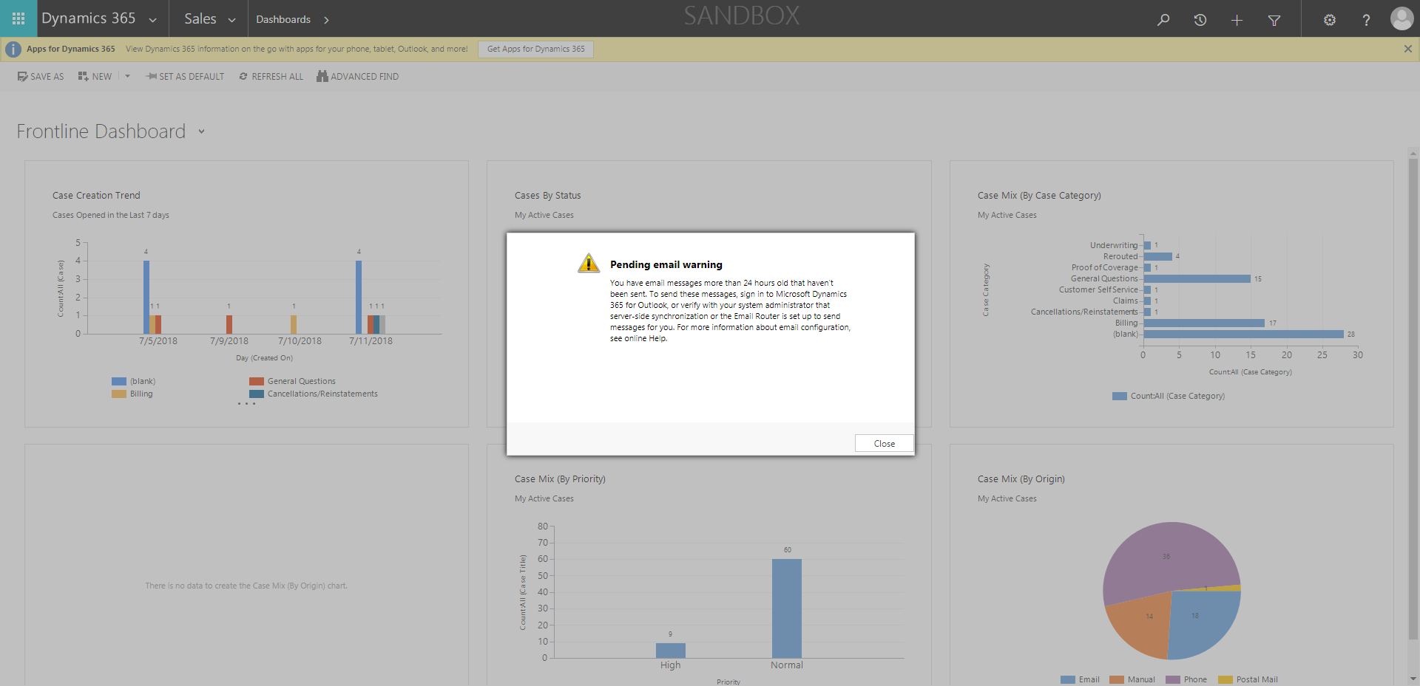

ContactManagement_Verify Contact notes _Instance44_12-Jul-2018_06-28-18_AM_Validatingcontactentitynavigation.png

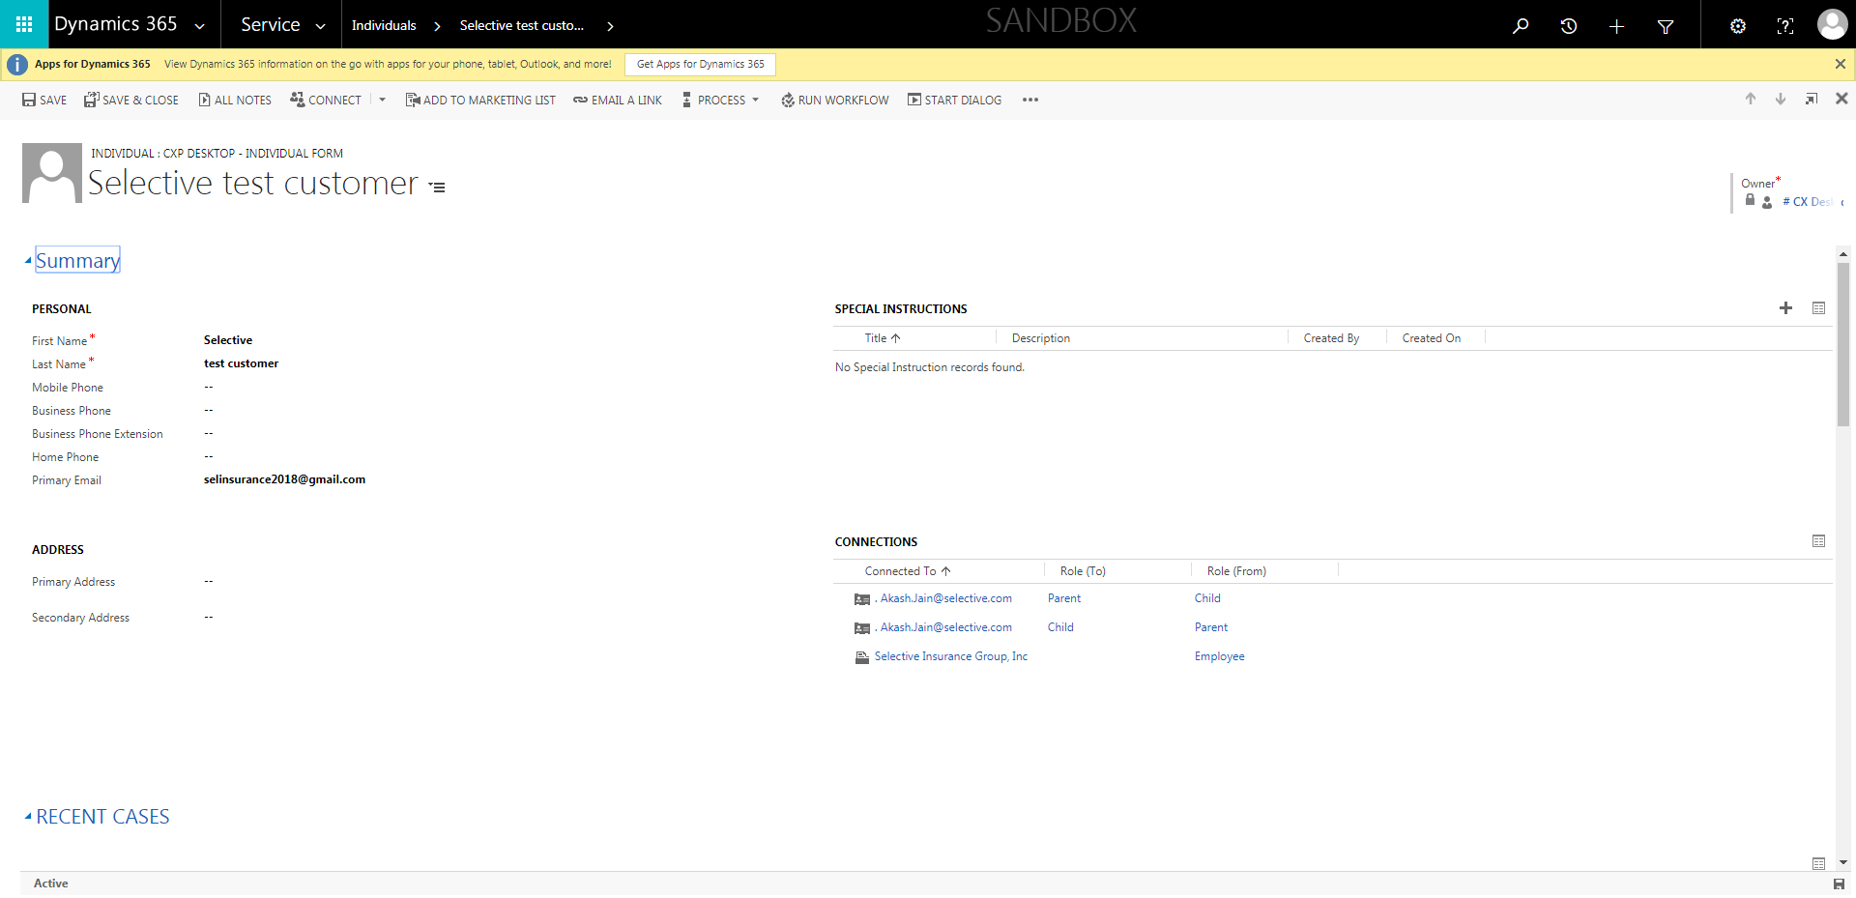

ContactManagement_Verify Contact notes _Instance44_12-Jul-2018_06-26-44_AM_MouseClickActiononStaleElement.png

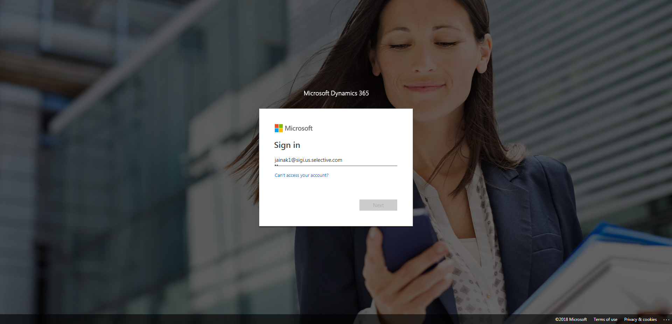

ContactManagement_Verify Contact notes _Instance44_12-Jul-2018_06-26-42_AM_EnterTextAction.png

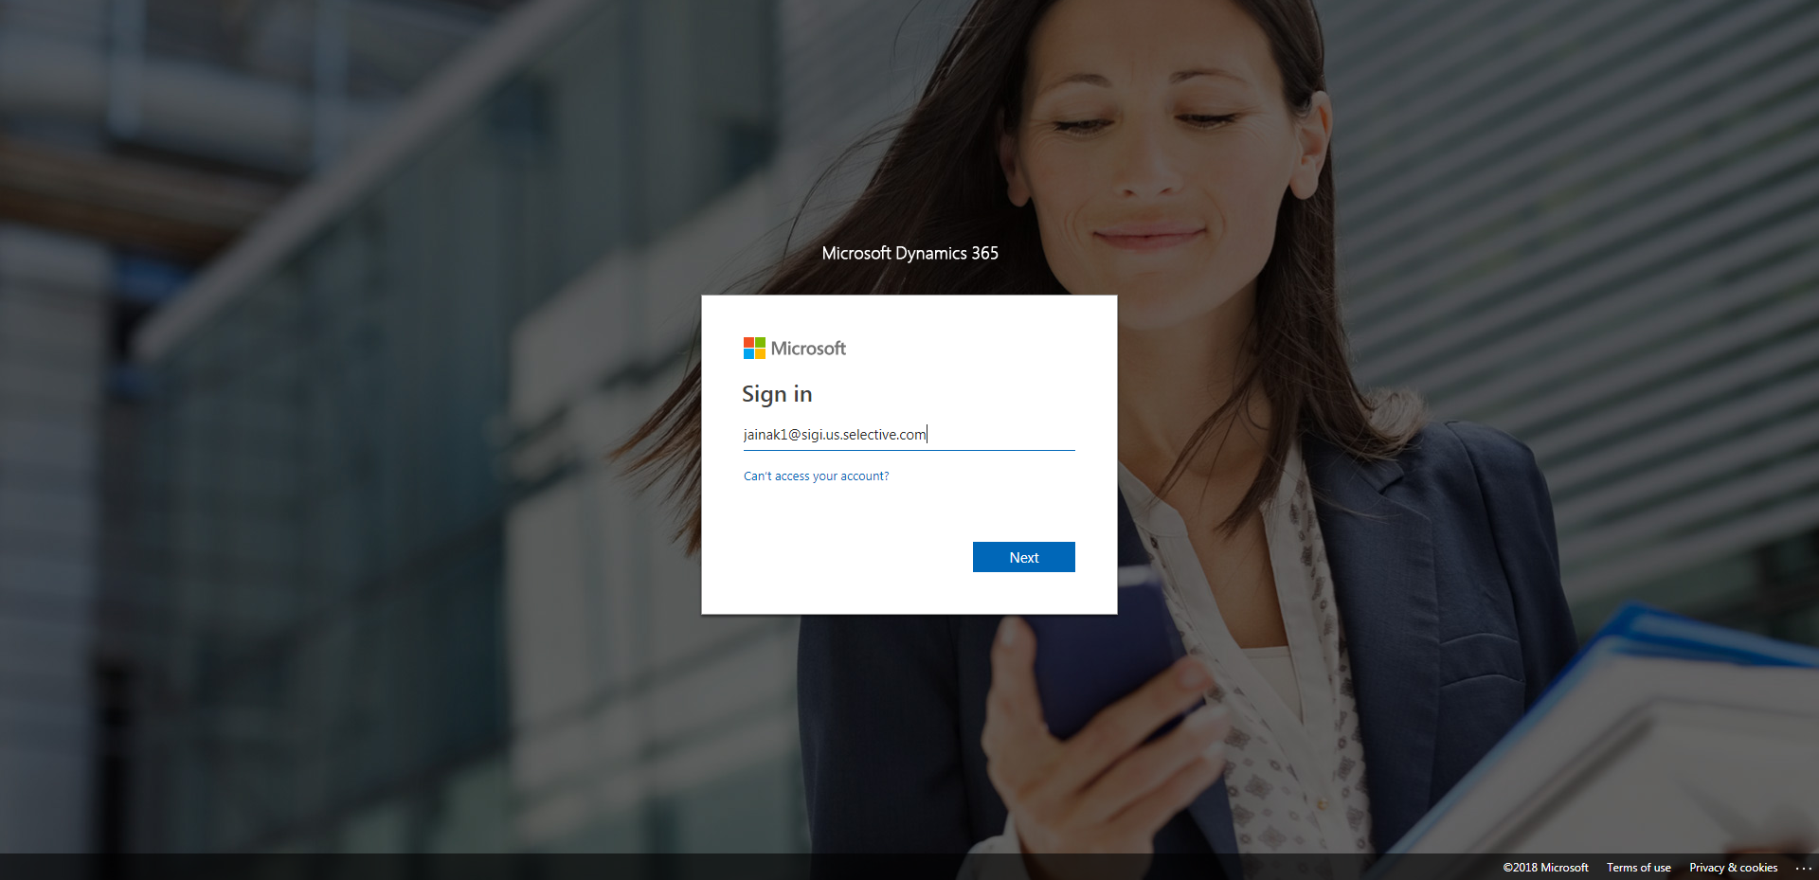

ContactManagement_Verify Contact notes _Instance44_12-Jul-2018_06-27-09_AM_SingleSignOn.png

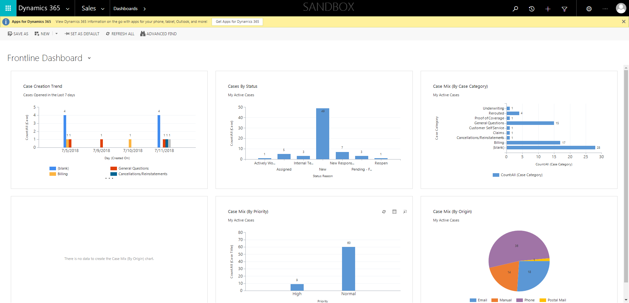

ContactManagement_Verify Contact notes _Instance44_12-Jul-2018_06-28-29_AM_VerifyingAllNotesofanindividual.png

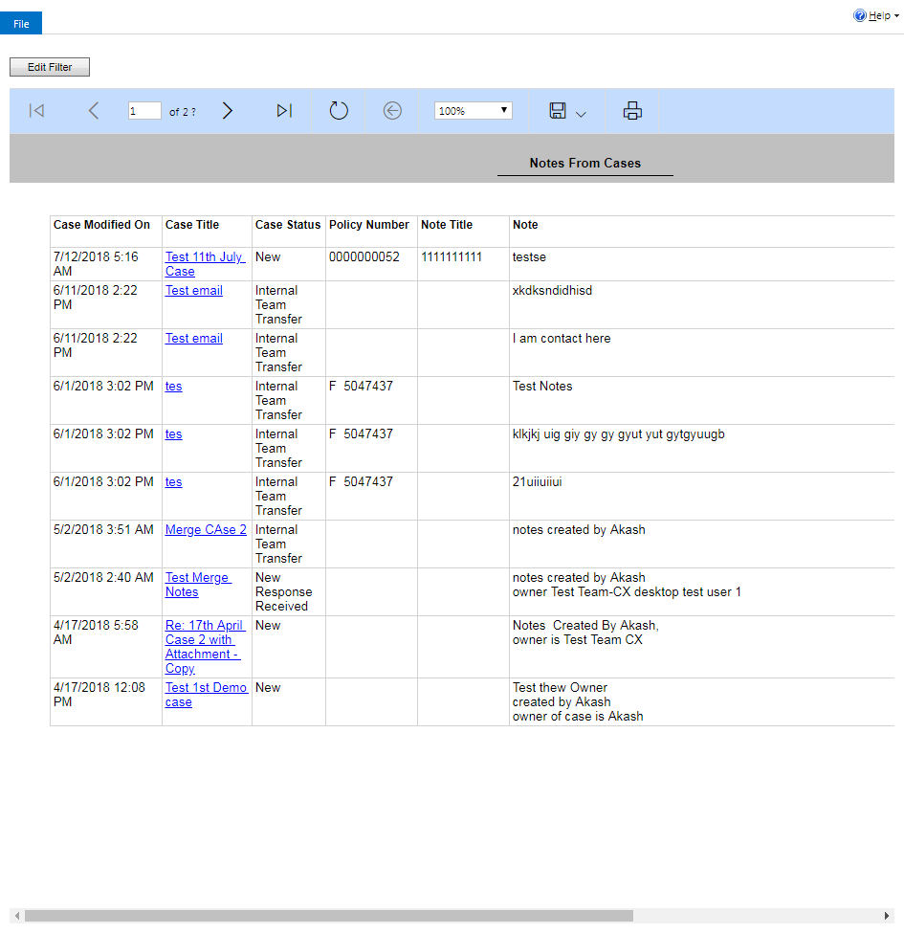

ContactManagement_Verify Contact notes _Instance44_12-Jul-2018_06-28-27_AM_VerifyingLatestNotesofanindividual.png



ContactManagement_Verify Contact notes _Instance44_12-Jul-2018_06-26-40_AM_MouseClickActiononStaleElement.png

